

Travlr Website Design Plan

CS 465 Project Software Design Document
Version 1.0

Table of Contents

CS 465 Project Software Design Document 1
Table of Contents 2
Document Revision History 2
Instructions 2
Executive Summary 3
Design Constraints 3
System Architecture View 3
Component Diagram 3
Sequence Diagram 4
Class Diagram 4
API Endpoints 4
The User Interface 4

Document Revision History

Version | Date | Author | Comments
1.0 | 5/23/25 | Darius Quick | Completed the Executive Summary, Design Constraints, and System Architecture View: Component Diagram

Instructions

Fill in all bracketed information on page one (the cover page), in the Document Revision History table, and below each header. Under each header, remove the bracketed prompt and write your own paragraph response covering the indicated information.

Executive Summary

To build the Travlr website I used the main components of the MEAN technology stack, which is comprised MongoDB, Express, Angular, and Node.js. These technologies are highly functional when creating a full stack program from scratch, having many different options to suit the builder.

The Mean Stack allows people who want to build a program that has a great user interface to be successful. With cross-platform support, the user experience will be rendered quickly.

Certain features from using the MEAN stack make building the program cost effective. This includes providing a streamlined, open-source, free architecture while allowing rapid transition from prototyping to commercial availability. An SPA(Single page application) is used for the administration tasks such as allowing admins to update, add, or remove site information with ease.

Also, if a different technology like a tablet or smartphone is used, the MEAN stack limits the amount of changes would be necessary for different versions to be created.

Design Constraints

There are a couple of Design Constraints for using the MEAN stack technologies and an SPA that I will explain.

The raw files will be stored in MongoDB, the M in MEAN, which has several drawbacks. First off, big documents are not supported by MongoDB. A single document, such as a text file, photo, etc., can only be 16 Mb in size. Additionally, MongoDB anticipates that the server will have a large hard drive and storage. Over time, this may result in somewhat higher cloud expenses.
Search engine optimization (SEO) is another restriction of building the website as an SPA. "Your site will be penalized if your server-generated HTML is judged to be too distinct from the SPA content". However, there shouldn't be any penalties because only the administrative tools—not the customer-facing portion—will be constructed as an SPA.

System Architecture View

The following three sections examine and illustrate the various parts, the class structure (Class Diagram), the messages that are passed between objects (Sequence Diagram), and the class structure (Objects).
Diagram of Components
The component diagram for the entire Travlr site is displayed in Figure 1. Angular.js is executing in the client-side, or customer's browser, which is sometimes referred to as the front-end and is indicated in green. The graphics library and the ability to save sessions (customize customer interactions or configure entitlements and persist them) are two of the lesser components that the clientside will have made possible by the MEAN stack. Through the necessary interfaces, the client-side communicates with the server and database components. For instance, the Client Session uses one of these interfaces to retrieve a user's entitlements that are kept on the Server component Authentication server.
Although it is external to the server, the database component is physically located on it. Additionally, it can connect to the client or server on its own. The information files required for the website, such as pictures and package descriptions (stored as JSON files), will be kept in the MongoDB. Depending on the kind of call, the documents saved in MongoDB can be served to the front-end or the back-end.

The tools required for user authentication, managing communication between MongoDB and the front-end are found in the Server component, also referred to as the back-end. Mongoose middleware, which enables data model schema enforcement at the application layer, will be used to connect with MongoDB.

REST APIs will be used to connect the three parts. One kind of web service that enables system-to-system interaction and communication over the internet is called a REST API (Representational State Transfer Application Programming Interface). REST APIs are frequently used to facilitate communication between various services or software programs. They give clients a consistent method for requesting and modifying data from a server. In response, the server gives the requested data in a structured manner, usually in XML (eXtensible Markup Language) or JSON (JavaScript Object Notation). These APIs will be used for all calls between the components.

Component Diagram

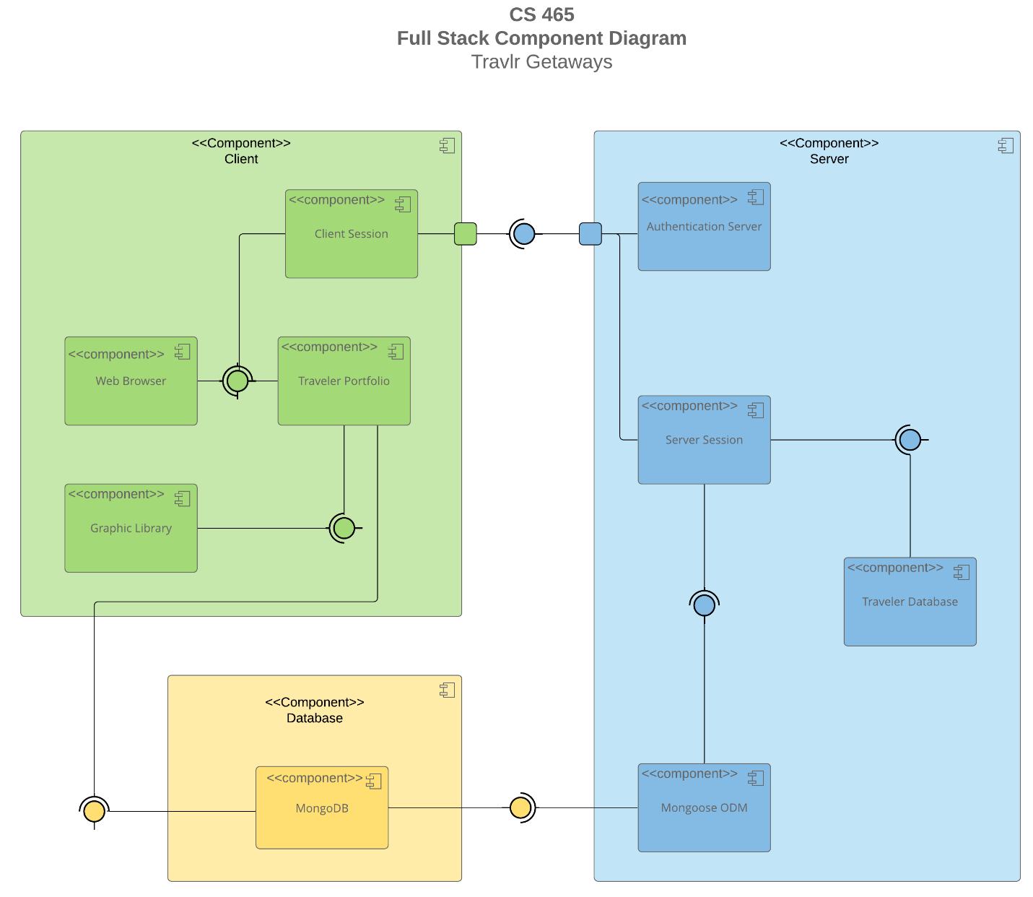

A text version of the component diagram is available: CS 465 Full Stack Component Diagram Text Version.

<Describe the overall system architecture of the web application by referring to the component diagram above. Identify the significant components that will be used and their relationships to one another.>

Sequence Diagram

The actor, in this case the user, is at the beginning of the sequence diagram. The frontend router directs the actor to one of the site's views or templates after they enter a route. The matching controller is called by the view, filling in the template, rendering, and returning the view that will be shown to the actor. To obtain bits of information, the frontend controller calls functions in the HTTP service. The controller receives the output of that function. Through API calls to designated routes, the HTTP service establishes a connection between the frontend and the backend. After receiving the route from the frontend, the backend router calls the relevant backend controller. The backend controller uses Mongoose to call the database after the router calls it. After receiving the returned data, the controller 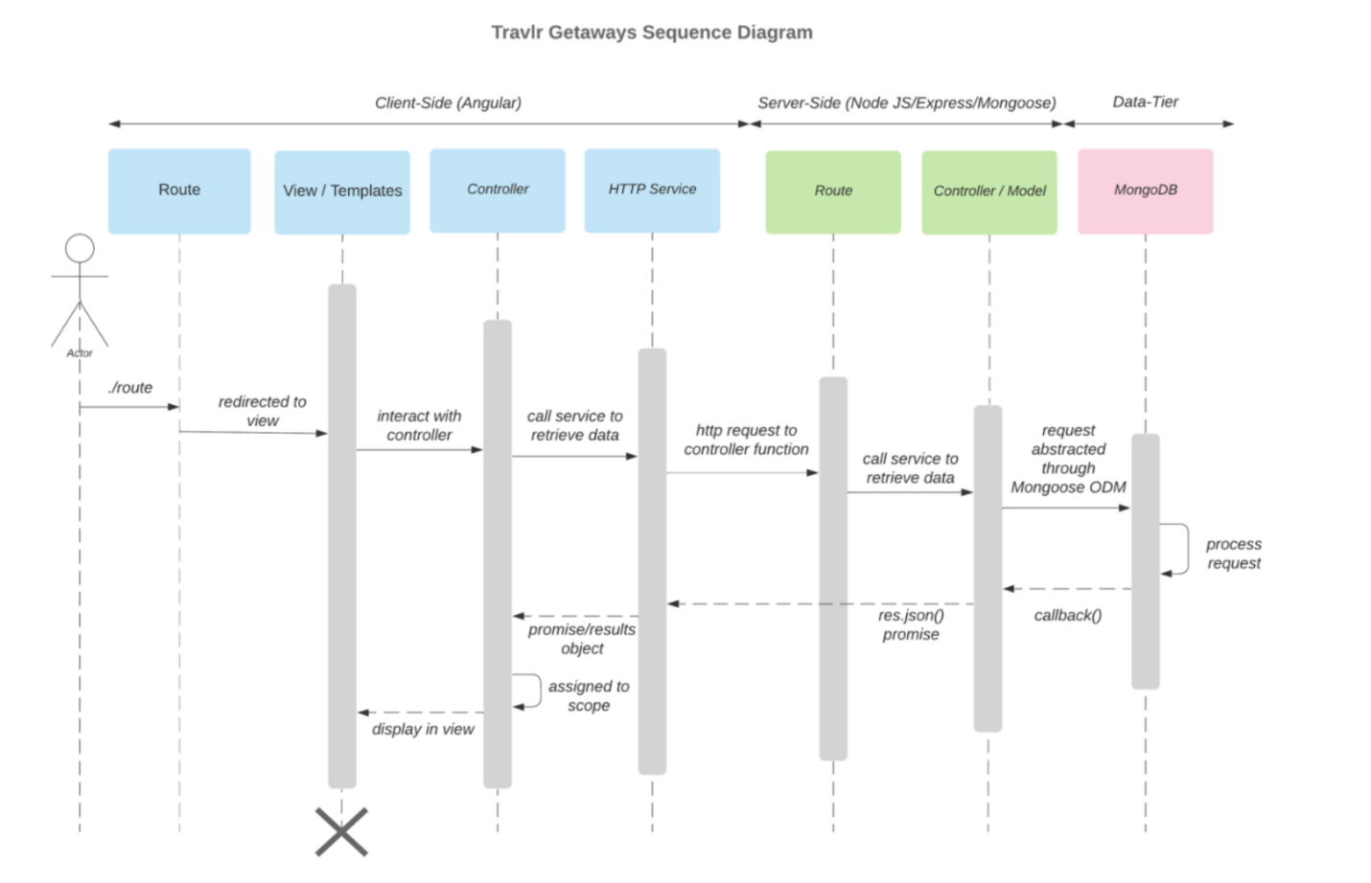sends the query to the MongoDB database, which processes it and returns the outcome.

Class Diagram

A name property and additional fields specific to each mode of transportation are present in the CruiseInfo, FlightInfo, and HotelInfo classes. Additionally, each one inherits the TripInfo class, which has properties for the origin and destination locations as well as start and return data. Each of the following: CruiseBooking, FlightBooking, and HotelBooking are associated with the TravellerInfo class and their respective Info classes. The Booking classes and the TravelAgent class have zero-to-many relationships in both ways. In addition, the TravelAgent class has a one-to-many link with the MembershipAdmin class and relationships with the CruiseInfo, FlightInfo, HotelInfo, and TravellerInfo6 classes. The MemberAccount class is inherited by the TravellerInfo class. There is an aggregate connection between the MemberAccount class and the MembershipAdmin class. There is an aggregate relationship between the CruiseInfo, FlightInfo, and HotelInfo classes and the Itinerary class.

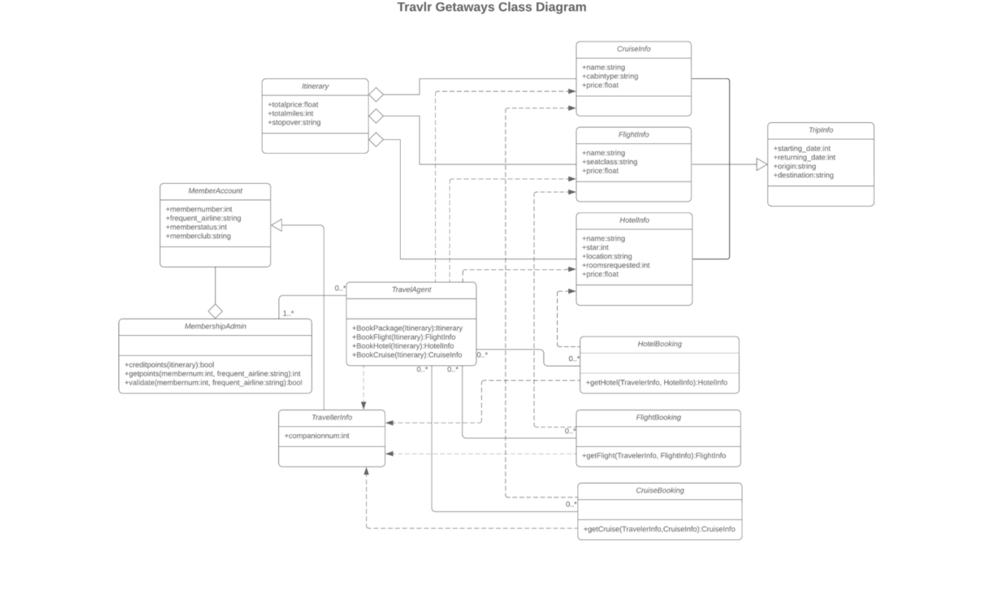

API Endpoints

<Exposing RESTful endpoints is a design approach to enable an application to participate in a larger ecosystem. Document each endpoint in the table below, including the HTTP method, purpose, URL, and notes.>

Method | Purpose | URL | Notes
POST | Add a trip | /api/trips | Add anew trip to the database
GET | Retrieve a single trip | /api/trips/:tripcode | Returns a single trip, identified by the trip code at the end of the URL
PUT | Update a single trip | /api/trips/:tripcode | Updates a single trip, identified by the trip code at the end of the URL
DELETE | Deletes a single trip | /api/trips/:tripcode | Deletes a single trip, identified by the trip code at the end of the URL
GET | Retrieve a list of trips | /api/trips | Returns all trips

The User Interface

A Trip I added(Fourth Trip):

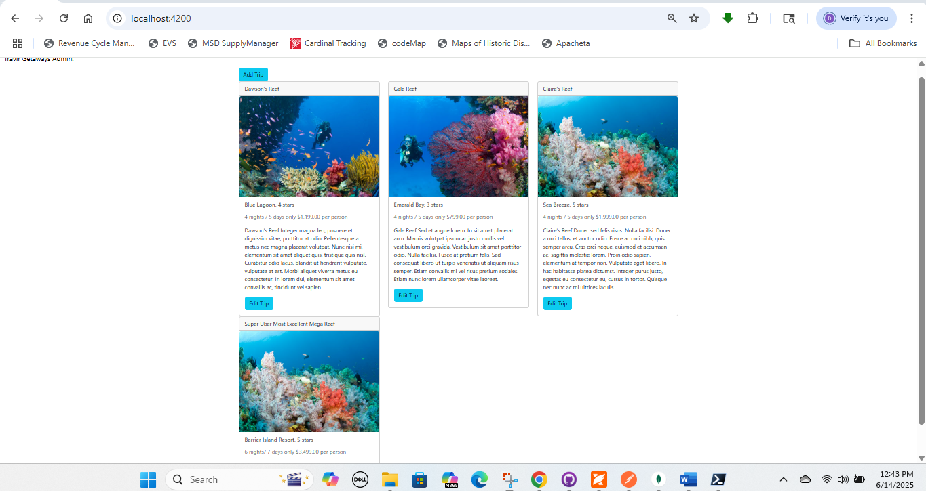

Edit Screen:

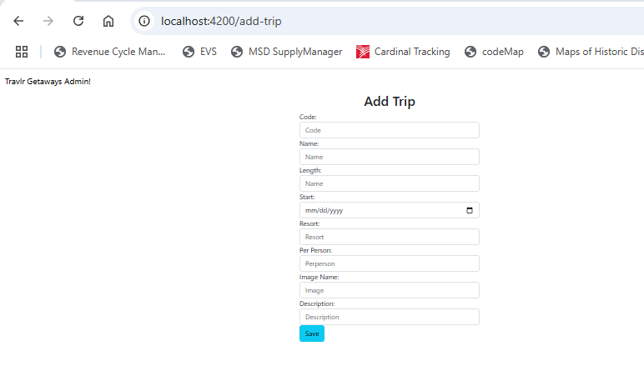

Update Screen:

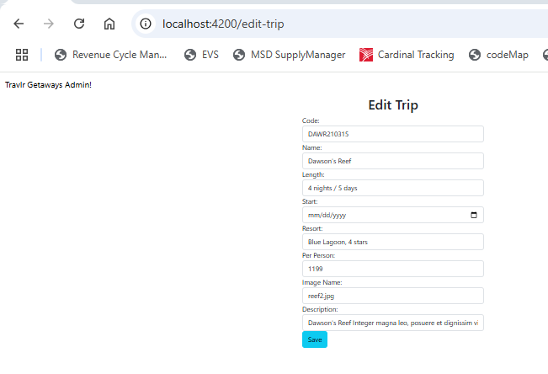

Both project structures have unique qualities that make them desirable; the Angular structure takes a dynamic approach, while the Express structure takes a minimalistic one. The model viewcontroller pattern serves as the foundation for both frameworks. A JavaScript framework based on typescript, Angular may help a variety of businesses develop scalable online applications. The Express is an open-source server-side framework with direct components of the MEAN, MEVN, and MERN stacks that was developed for Node.js and is written in JavaScript.

The organization wishes to replace the web application with an SPA when employees interact with it and use it to complete their timesheets. When users interact and navigate across the application, the SPAs can enable rich client-side functionality that removes the need for the page to reload. The SPAs can load rapidly and retrieve data in the background of the application. The employees' time inputs will be gathered by the web application from their timesheets and transmitted to the consolidated timesheet database over the API. Similarly, supervisors will be able to approve employees' timesheet inputs through the online application.

